Logging in to your Google Account  - Chrome Browser (ideal)  - Signing into Chrome Browser vs. Account  - Browser:  - Full sync of all your tools  - Identifies you across all platforms  - Keeps you signed in until you purposely sign out  - Multiple accounts can be saved and toggled between (opens new window)  - Account  - Access to apps (Drive, Docs, Mail etc) but not to bookmarks, extensions  - May not be able to access files shared privately with your account | 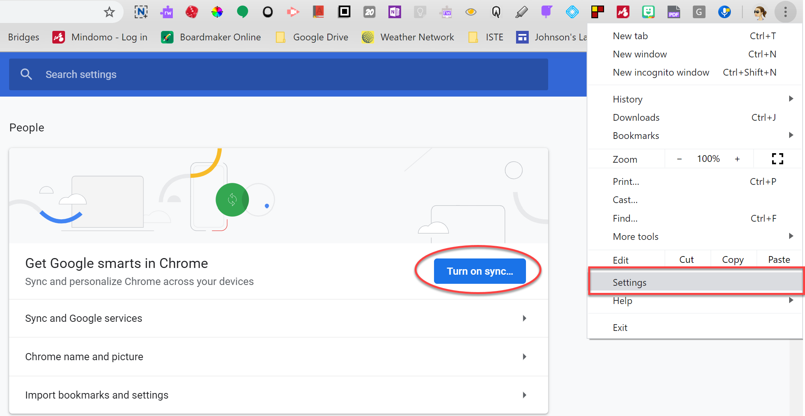  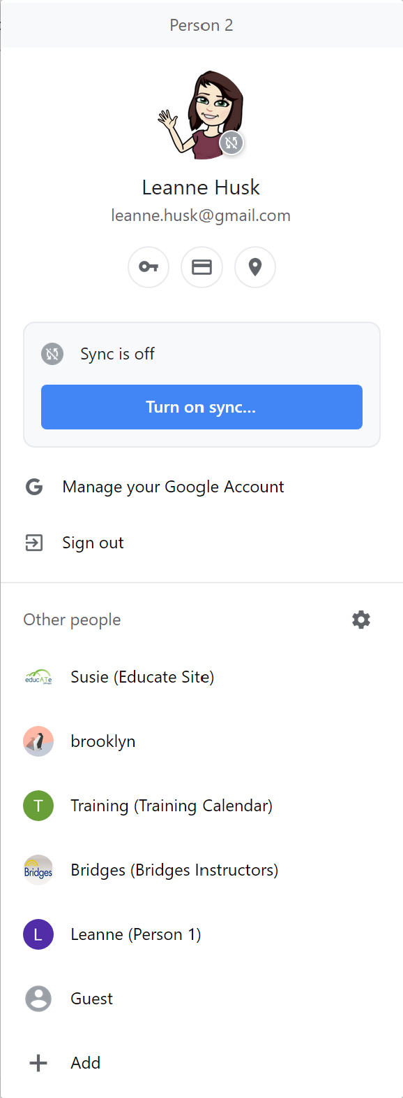  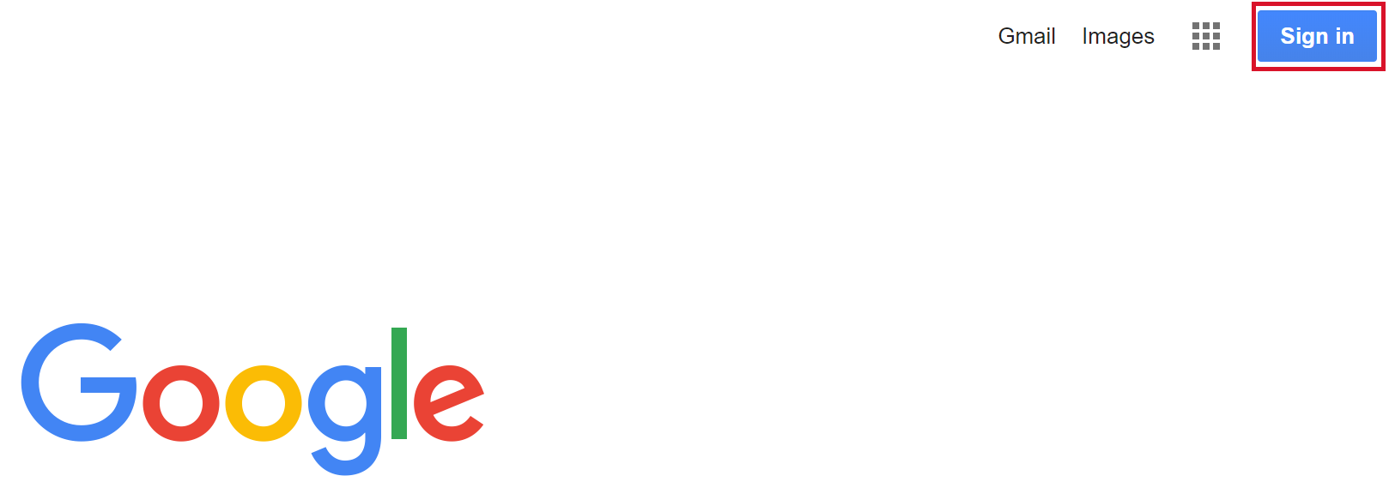
Accessing Google Drive  - Access through the “Waffle” of apps  - The “file cabinet” of your materials  - Materials can have different levels of access  - Editor  - Comment Only  - View Only | 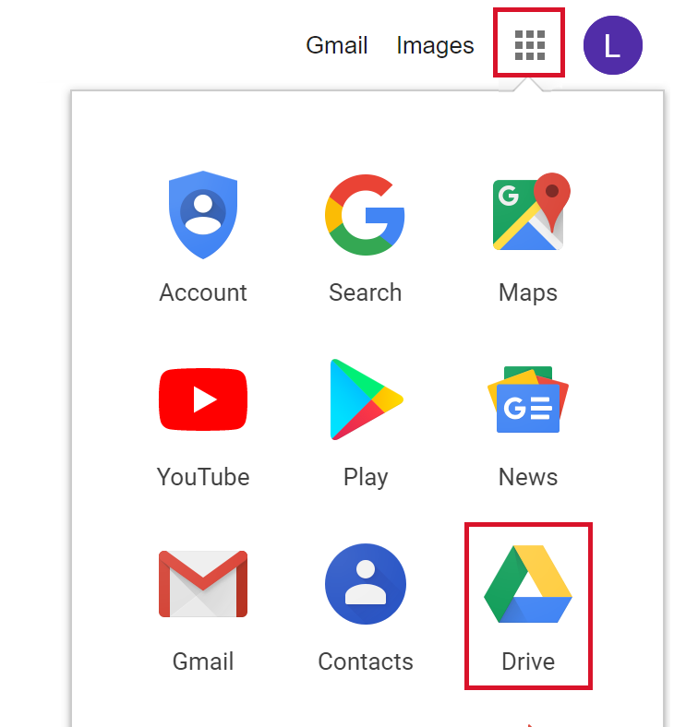
Google Drive  - My Drive  - Your personal materials  - Only accessible by you unless you share it  - Organizing  - Creating folders/subfolders  - Moving Files  - Uploading files  - File compatibility (i.e. Word = Docs)  - Opening Microsoft files  - Editing as docx  - Saving as Doc  - Navigation and Searching for files  - Working offline  - https://www.google.ca/drive/download/ | 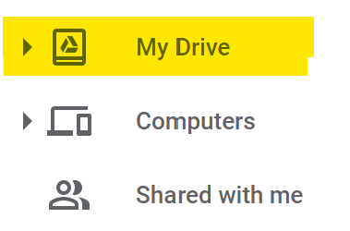  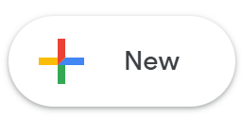  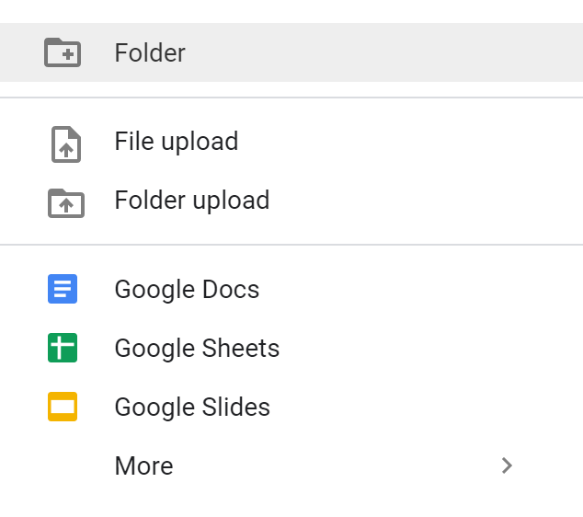  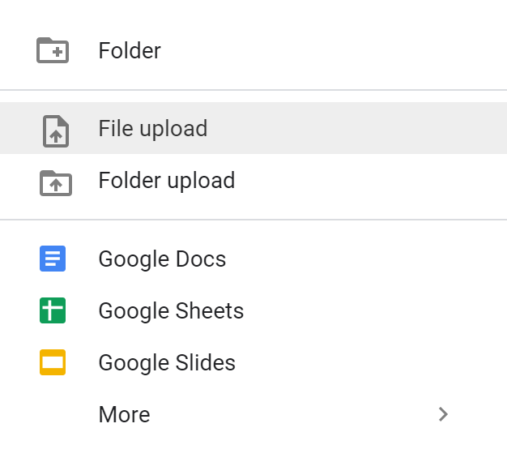  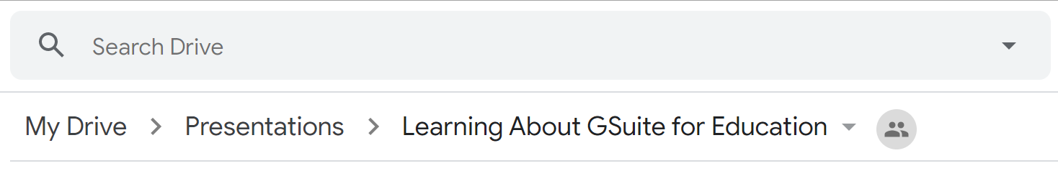  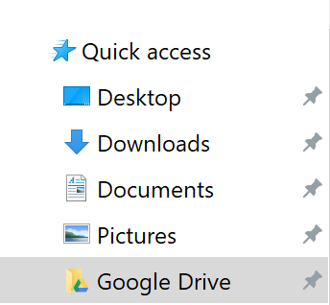
Google Docs  - Creating new documents  - New documents will be saved wherever they are created; create within the folder you want it to live in, to minimize steps and avoid misplacing files  - Documents will automatically adopt the permissions of the folder it’s created in - unless you change it  - NAME YOUR FILES  - Autosave won’t remind you  - Collaborating/editing  - According to permissions  - Revision History  - Recovering lost work  - Identifying contributors | 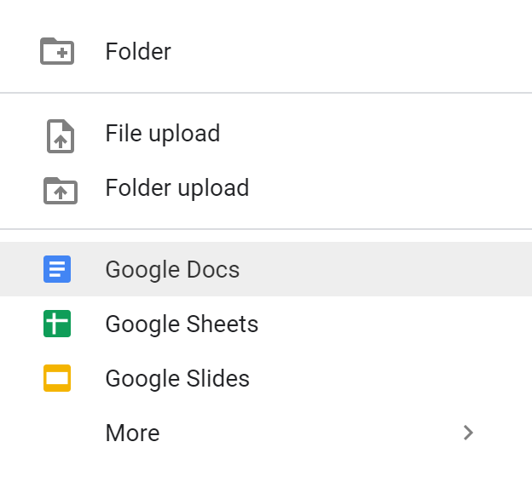  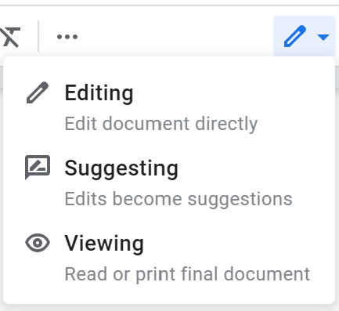  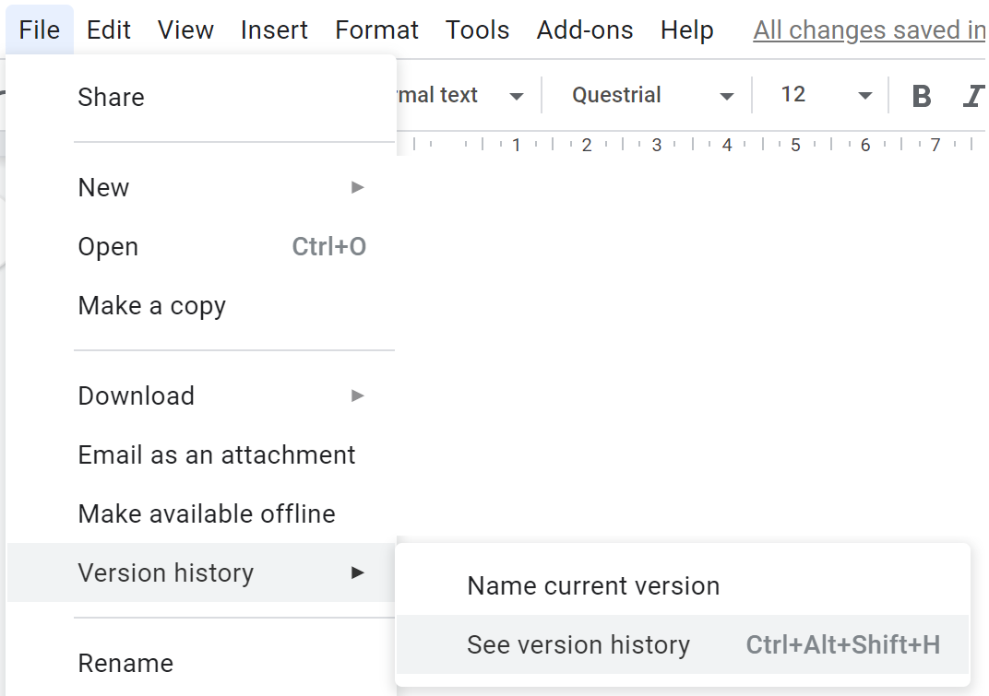
File Sharing  Sharing  - Setting permissions  - Using links  - Downloading files to email as attachments  Receiving  - Drive > Shared with me - “mailbox”  - Access/permissions of all the files in Shared with me will vary and is controlled by the owner(s)  - Moving files/folders to My Drive  - Drag and drop (maintains share)  - Make a Copy (breaks share) | 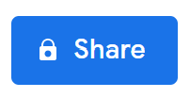  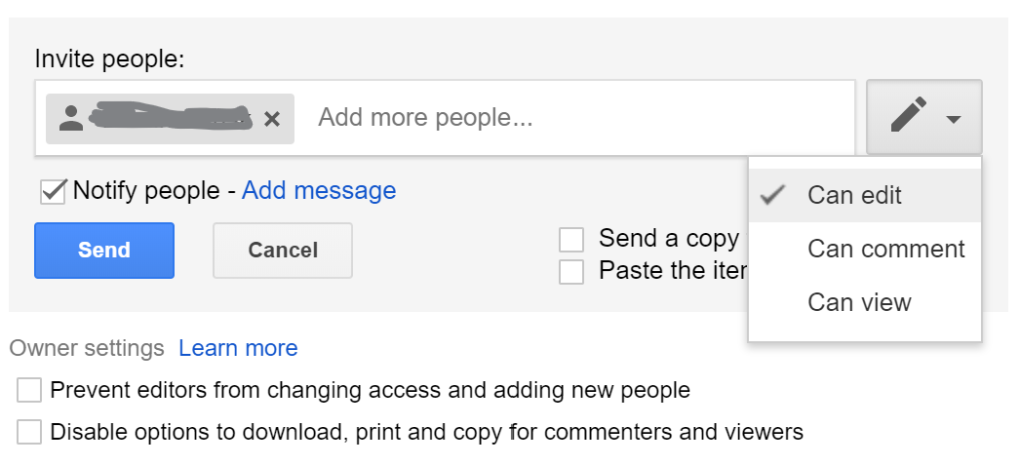  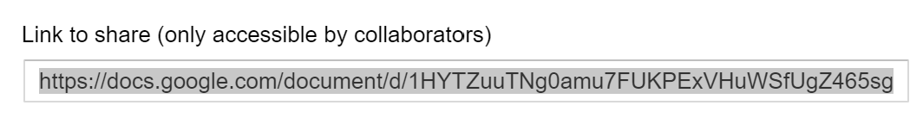  Tiny URL - https://tinyurl.com/  Bit.ly - https://app.bitly.com/  